# **Game on**

**Zoe's avatar**

[Zoe](https://substack.com/@zoeffc)

Aug 02, 2024

Share

Hey friends!

My sister just got a puppy (pictures at the end of the note) and this puppy has two modes: play and sleep. Play has always been important in my household. However, over the course of my life, I have found that I go through phases of intense devotion to work or skills that take me away from play. This week I want to talk about play as adults.

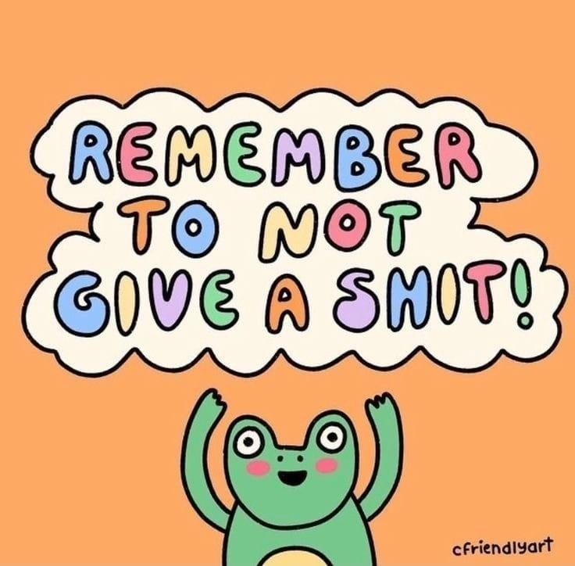

First some housekeeping:

📫 If a friend forwarded you this newsletter (then you have some really cool friends), and you may want to consider joining us [*here*](https://femme-futures.beehiiv.com/subscribe) for regular updates.

[Subscribe](https://femme-futures.beehiiv.com/subscribe)

🧲 Got some thoughts you want to share? Join us on [*Discord*](https://discord.gg/592wuyvx?utm_source=femme-futures.beehiiv.com&utm_medium=referral&utm_campaign=game-on) to chat all things newsletter and corporate life.

[Discord](https://discord.gg/N84WxemQ?utm_source=femme-futures.beehiiv.com&utm_medium=referral&utm_campaign=game-on)

Originally, this was going to be about work-life balance. While that is certainly still part of this larger conversation, I think that if we think about “play” first, we can get more excited about it. “Work-life balance” feels like an unobtainable goal where life is filled with surfing and you never experience stress. Play, however, is much more obtainable.

There seems to be a myth that adults don’t play. I know that I believed that throughout high school, as I was desperate to become an adult. Play was something cordoned off for recess and preschoolers. So imagine my surprise to learn that adults play, too!

Ways Adults Play

Play looks different for different people. I will define play as an activity that creates pleasure or joy.

Have you ever watched an adult play peek-a-boo with a baby? I would be hard-pressed to tell you who is getting more enjoyment or pleasure out of that. Adults play much the same as children when the two groups interact. And puppies. We certainly play with puppies.

Then there’s sports. In the last couple of weeks, I had conversations where my friends reflected to me that — particularly as people who didn’t play sports growing up — we have gravitated towards some form of sport as adults, be it cycling, running, rugby, or climbing. These are things that we do not to be exceptional at them, but just because they bring joy to our lives in some way or another. Whereas, when we were younger, we were encouraged to think about sports as something that could take you to the Olympics, or something that would make you hotter, as we have matured, a lot of that pressure has eased off of sports and we’ve taken to it from an intrinsic drive.

Maybe think about a moment when you were out with friends. Perhaps you were laughing over dinner, or pointing out cute (or horrifically ugly) clothes to each other, or taking a walk. This is why so many people drink and spend all night in night clubs or at concerts dancing. That’s also a form of play.

Reasons for Play

I was rock climbing last night and must have spent at least half of my time laughing and chatting with my friends. The climbing gym has become a space that gives me a sense of belonging, as well as a sense of ambition and accomplishment. I like the social aspect of the sport, but that isn’t everyone’s reason for playing.

My godfather is a surfer. He moved to Sydney, Australia for the surf when he was in his late twenties and has been there since. He is a ridiculously charming and outgoing guy, but when he is in the water, he is quiet and calm and is not performing for anyone but himself. That is what his system needs and what gives him joy and keeps him coming back to the water day after day.

Play is a way to disconnect from work. As we all know work is not always easy. It comes with its fair share of stress, no matter how much you believe in the mission or love your coworkers. We need to be able to step away from it mentally in order to remember that we are full and complex humans. I have found that through play, I am able to allow those major work stressors to move to the back burner, or fade out completely. This way, I am able to come to my relationships and hobbies a slightly better version of myself.

“But I Can’t Play”  
I get it. There have been moments in my life where play felt impossible. I have lost loved ones, gone through spells of depression, and navigated major life transitions, just like you. Play is not always easy and it is not always accessible. Sometimes play can make you feel incredibly guilty, because how dare you be happy when everything else is so awful. I’ve been there.

If that is where you are as you are reading this, please know that that is totally ok. I have every confidence that you are showing up as best as you are able to each day. My ask is that you be gentle with yourself.

Humor has gotten me and my family through some of our darkest days. I have laughed in hospice rooms and through tears. For me, that has made it easier to get through it. It is even better if you are not the only one laughing. I urge you to embrace these moments of levity, especially in darkness. Trust that humor, joy, and pleasure will be there for you to come back to when you are able.

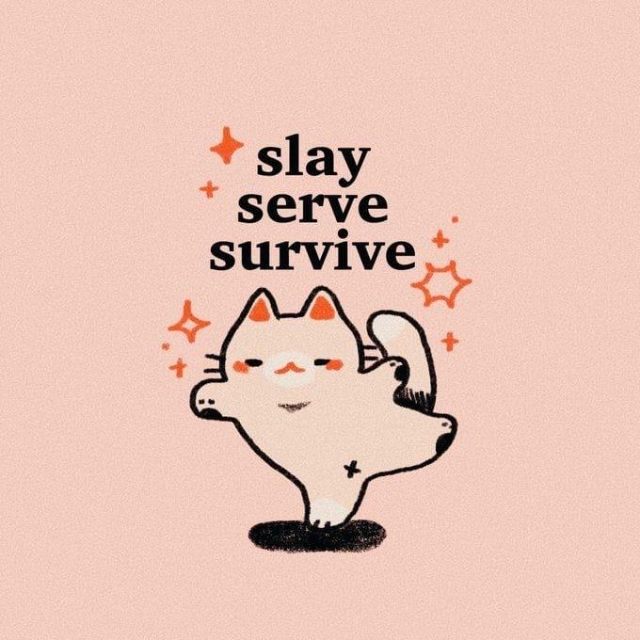

*Artist Unknown*

I guess I am ending this where I began it: play, much like “work-life balance”, is something to be strived for an incorporated into our lives to the greatest extent that we are able. It will make us like ourselves more, have more people liking us, and being around more people that we like. It is the antidote for stress and sorrow, but that does not mean that it is easy. We aren’t always good at identifying those moments in our life that bring us joy — and sometimes our life just doesn’t hold a lot of them.

I hope that as you go through the next week, you can actively seek out play, be it big or little.

Game on,

Zoe

P.S. If you move to Australia to surf for the rest of your life though — please tell me so that I can live vicariously through you.



*This is Mia!*